Guided Capstone Project Report

Big Mountain Resort Ticket Price Increase Analysis and Modelling

By: Angela Dunston

Big Mountain Resort, a ski resort located in Montana, has access to 105 trails.They have recently installed an additional chair lift to help increase the distribution of visitors across the mountain, which will increase their operating costs by $1,540,000 this season**.** Although there are limitations to this approach**,** the resort's pricing strategy has been to charge a premium above the average price of resorts in its market segment. There's a suspicion that Big Mountain is not capitalizing on its facilities as much as it could. The business wants some guidance on how to select a better value for their ticket price.

This report provides the analysis and modelling performed to answer the question, “What opportunities exist for Big Mountain Resort to increase ticket prices by 20%

through reducing operational costs and efficient facility utilization by the end of next year?” The goal of this project is to build a predictive model for ticket prices based on a number of facilities, or properties, boasted by resorts. This model will be used to provide guidance for Big Mountain's pricing and future facility investment plans.

To perform the analysis, data was collected, organized, and defined to come up with a pricing model for ski resort tickets in our market segment. Data from ski_resort_data.csv was imported. Big Mountain Resort data was present in the original data and there were no missing values.

In Montana where our resort is located, we found that average ticket price is the same during weekends and weekdays and are relatively cheap compared to California, Utah and Nevada Resorts (See Figure 1). Some states have different price variations between Weekends and Weekdays and

most of them weekend prices are greater than weekday prices.

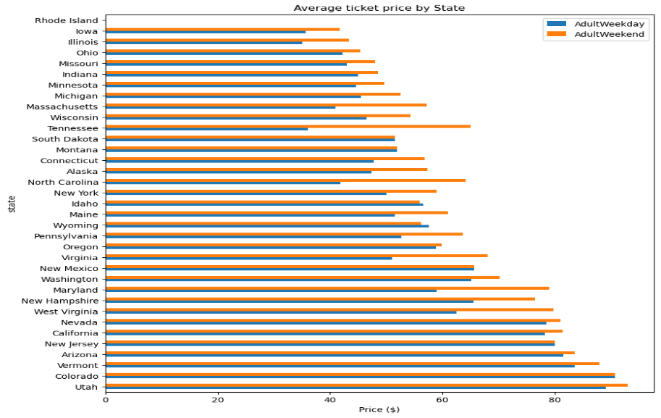

Figure 1: Average Ticket Price by State

In this phase of Big Mountain Resort ticket price data analysis, ticket price variation across states and the various features was explored. Features correlations with ticket prices were analyzed offering possible support to increasing the adult ticket prices. The best eight features included in the analysis were: The vertical drop, the snow making acreage, the number of total chairs, the number of fast quads, the number of runs, the longest run distance, the number of trams and the total skiable terrain acreage. The latter two had negative coefficients. Four features were deemed to have the most prominent relationships to the ticket price: the number of fastquads lifts, the number of runs, snow making acreage, and the vertical mountain drop height (See Figure 2).

Figure 2. A heat map representation of correlations between the adult weekend ticket price and all the features in the dataset.

The data was tested using two different models, linear and random forest. After testing both the linear model and random forest model, the project will be moving forward with the forest regression model. Comparison of the two demonstrated that performance on the test set was consistent cross-validation results. Additionally, the cross-validation mean absolute error was lower using the random forest regressor.

Four modeling scenarios were evaluated to explore an increase in ticket pricing, reduction in operational costs and efficient facility utilization for Big Mountain Resort. The summary below discusses the results of the evaluation.

1) Ticket Price**.**

The current Big Mountain Resort ticket price is $81 dollars whether this is during the weekend or a weekday. Big Mountain Resort modelled price is $95.87, actual price is $81.00. Big Mountain has amongst the highest number of total chairs, resorts with more appear to be outliers. Most resorts have no fast quads. Big Mountain has 3, which puts it high up that league table. There are some values much higher, but they are rare. Big Mountain compares well for the number of runs. There are some resorts with more, but not many. Big Mountain has one of the longest runs. Although it is just over half the length of the longest, the longer ones are rare. The vast majority of resorts, such as Big Mountain, have no trams. Big Mountain is amongst the resorts with the largest amount of skiable terrain. Key focus areas for Big Mountain Result could be installation of trams, adding number of runs, increasing vertical drop and marketing key features that set them apart such as number of chairs and skiable terrain.

2) Potential cost cutting or revenue generation measures

Four scenarios were considered with assumptions of 350,000 visitors for the season and five day stays accounting for 5 tickets each and 1,750,000 tickets. The four scenarios are as follows:

a) Permanently closing down up to 10 of the least used runs. This doesn't impact any other resort statistics. closing up to 10 runs, the model showed reducing 1-2 runs, decreases support for the current ticket price. Closing 3-5 runs, does not contribute greatly to further decline in ticket price

support. Closing more will have a more pronounced effect.

b) Increase the vertical drop by adding a run to a point 150 feet lower down but requiring the installation of an additional chair lift to bring skiers back up, without additional snow making coverage. Adding a run, increasing the vertical drop by 150 feet, and installing/operating an additional chair lift, the model suggested increased ticket price support by 1.99 dollars amounting to $3,474,638 dollars increased cash flow.

c) Adding 2 acres of snow making cover increased the ticket price support by $1.99 dollars amounting to $3,474,638 dollars increased cash flow

d) Increase the longest run by 0.2 mile to boast 3.5 miles length, requiring an additional snow making coverage of 4 acres. The model found no monetary gain to support an increase in ticket price.

The added operating cost of the new chairlift, $1,540,000 dollars per season may be offset by implementing scenarios 2 or 3, each generating $3,474,638 dollars in improved cash flow. With 1,750,000 tickets per season assumed, scenario 1 would lead to a worsening of cash flow amounting to $1,225,000, assuming a decrease of $0.7 in ticket price support. These three scenarios may be combined to varying degrees to achieve the optimal cash flow for the season. The first scenario may be done incrementally over time with monitoring of visitor volume response over time. The development of an application, possibly a web app, with a dashboard that allows dynamic changes of several of the features and variables with visualization of the outputs may be helpful to management in studying many more scenarios and combinations. The outputs may include ticket price predictions and improvements in cash flow and operating expenses.

With the information provided like ticket prices and the additional operating cost of the new chair lift, we were able to come up with initial models and suggestions for increased revenue and decreased operational cost. However, there were deficiencies noted with the data. For example, we did not have total operating cost of the resort to include costs for labor and maintenance. There are a lot of missing values that could have an impact on the final models specifically the ticket price. There is lack of information on rental and hotel fees, which may also impact the ticket pricing.

The model has certain assumptions related to more granular details and need further data analysis and comparisons, such as further investments and marketing, to improve the business model of Big Mountain. Customer feedback through surveys and market studies would confirm or identify

features important to clients.

Big Mountain Resort management may wish to be more involved in enhancing the designed model with further analyses and enhancement with additional available data, such as costs and analyzing additional features, presently available or under consideration. Developing an interactive model dashboard

for management use to analyze the changes in the features, costs, customer volume, among others. Investment in the further development of a machine learning model would improve future predictions of ticket price and cost improvements.